# Project Management Project

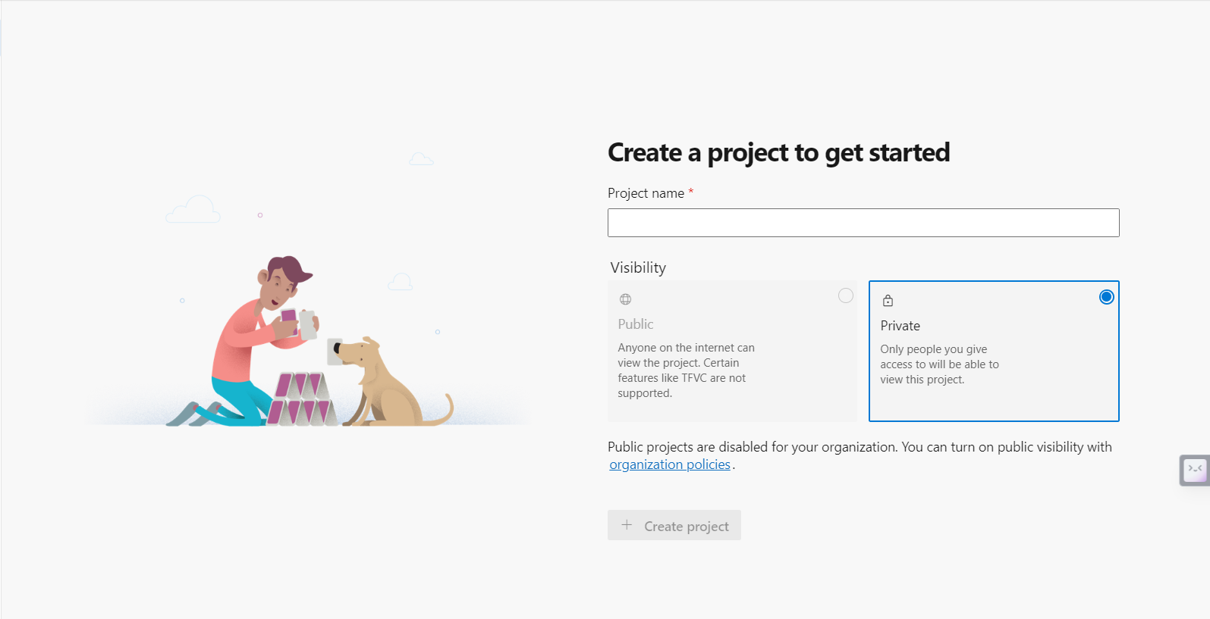

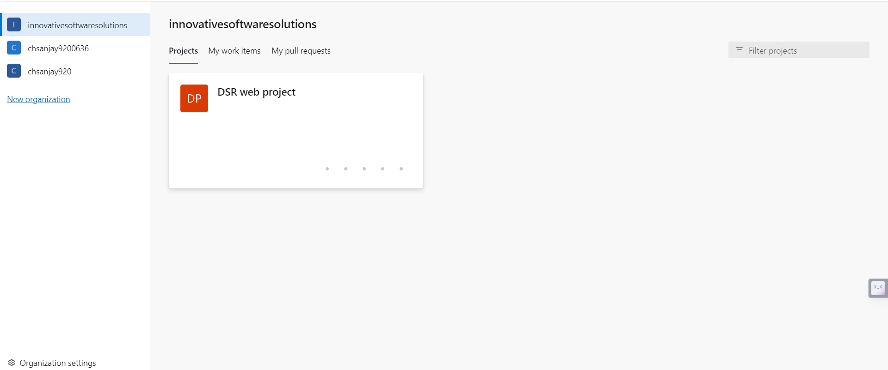

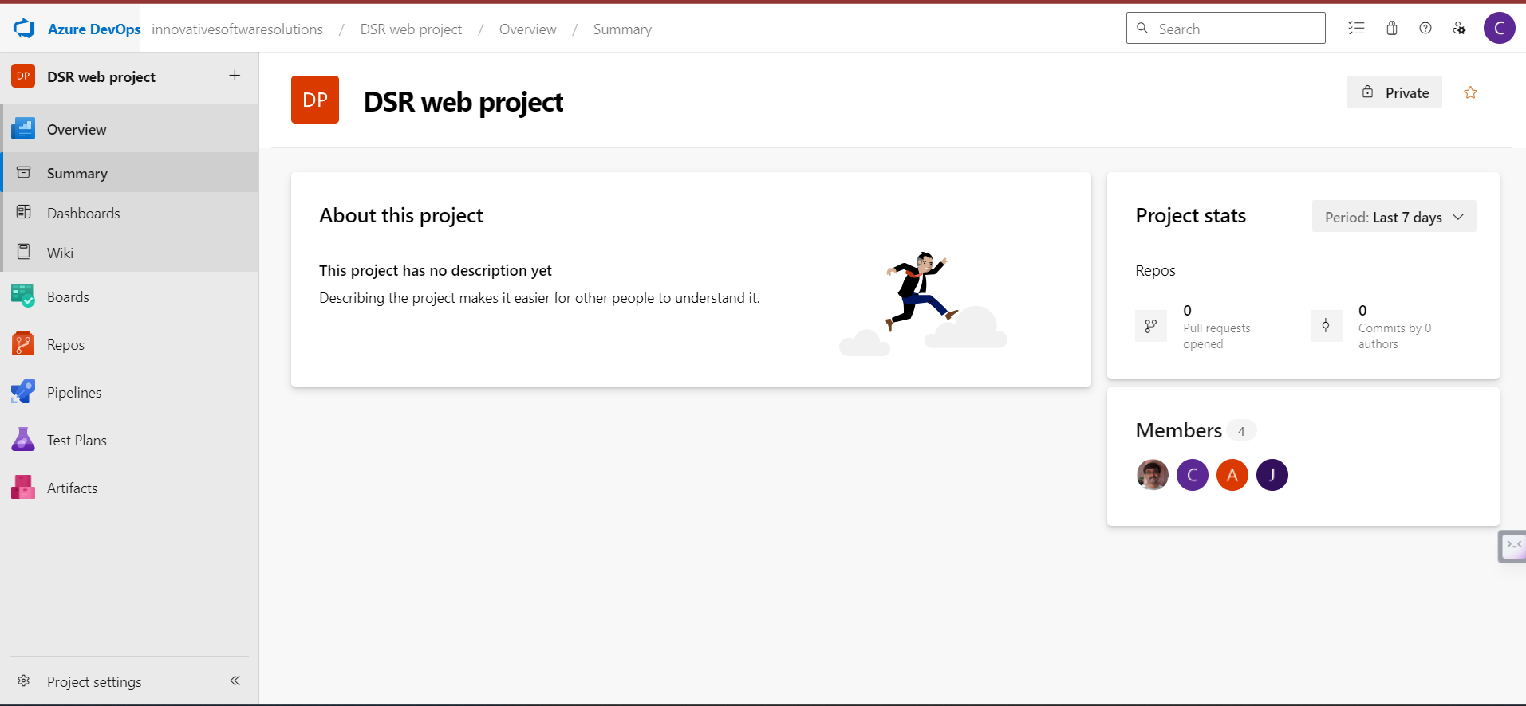

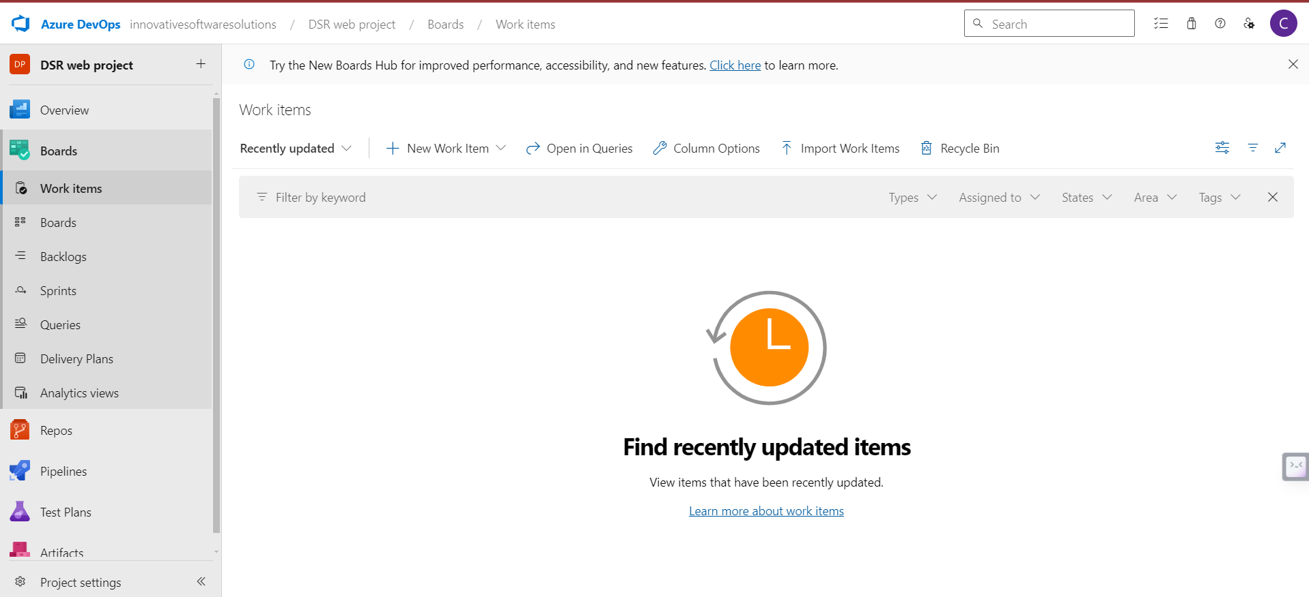

**BACKLOGS** :

Adding Backlog form (Admin, Teamlead) : ( Description, Priority, status {new} )

List backlogs based on priority. ( high, medium and low ) and status (Active, New and Completed)

**WORKITEMS** :

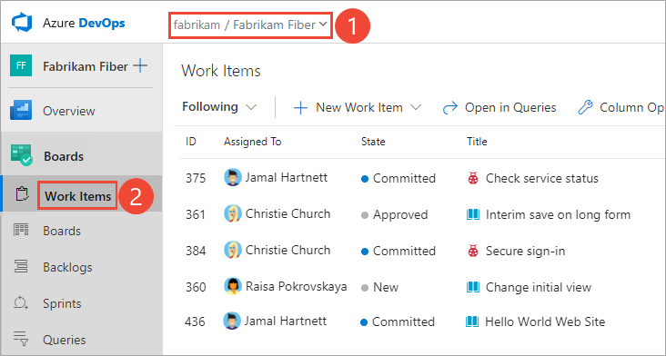

Listing all work items assigned for user.

( ID, Name, Titile, State)

**SPRINTS:**

Creating Sprint : (admin, teamlead)

List All Sprints.

**BOARDS:**

Listing all sprint wise pie charts.

--------------------------------------------------

Jira Board

Add Employee Form:

As a user, I want to have a form to add a new employee to the system.

Acceptance Criteria:

The form should capture essential employee details such as name, email, and role.

Upon submission, the employee information should be saved in the database.

Add Project Form:

As a user, I want to have a form to add a new project to the system.

Acceptance Criteria:

The form should collect project details, including name, description, and start date.

Upon submission, the project information should be stored in the database.

Add Task Form:

As a user, I want a form to add a new task related to a project.

Acceptance Criteria:

The form should include fields for task name, description, due date, and project association.

The task information should be saved in the database when the form is submitted.

Add Story Form:

As a user, I want a form to add a new user story related to a project.

Acceptance Criteria:

The form should capture user story details, including title, description, and project association.

The user story information should be saved in the database upon submission.

Add Sprint Form:

As a user, I want a form to add a new sprint to a project.

Acceptance Criteria:

The form should include fields for sprint name, start date, end date, and project association.

Upon submission, the sprint information should be stored in the database.

List Employees Route:

As a user, I want to view a list of all employees in the system.

Acceptance Criteria:

There should be a dedicated route (/employees) that displays a paginated list of all employees.

Each entry in the list should show key information about the employee.

List Projects Route:

As a user, I want to see a list of all projects available in the system.

Acceptance Criteria:

There should be a dedicated route (/projects) that displays a paginated list of all projects.

Each entry in the list should provide essential details about the project.

List Tasks Route:

As a user, I want to view a list of tasks associated with a specific project.

Acceptance Criteria:

There should be a route (/projects/:projectId/tasks) that displays a paginated list of tasks for a specific project.

Each entry in the list should show relevant information about the task.

List User Stories Route:

As a user, I want to see a list of user stories related to a specific project.

Acceptance Criteria:

There should be a route (/projects/:projectId/user-stories) that displays a paginated list of user stories for a specific project.

Each entry in the list should provide details about the user story.

List Sprints Route:

As a user, I want to view a list of all sprints associated with a project.

Acceptance Criteria:

There should be a route (/projects/:projectId/sprints) that displays a paginated list of sprints for a specific project.

Each entry in the list should show relevant details about the sprint.

Form Validation - Add Employee:

As a user, I want the "Add Employee" form to validate input data to ensure accuracy.

Acceptance Criteria:

Display appropriate error messages for missing or invalid input.

Ensure that the form cannot be submitted until all required fields are filled correctly.

Provide visual indicators for required fields.

Alerts - Add Employee:

As a user, I want to receive feedback through alerts after submitting the "Add Employee" form.

Acceptance Criteria:

Display a success alert if the employee is added successfully.

Show an error alert if there is an issue with the submission, providing details about the error.

Form Validation - Add Project:

As a user, I want the "Add Project" form to validate input data to prevent errors.

Acceptance Criteria:

Implement validation for fields like project name and start date.

Ensure that the form prevents submission with invalid or missing data.

Alerts - Add Project:

As a user, I want to see alerts after submitting the "Add Project" form.

Acceptance Criteria:

Display a success alert when the project is added successfully.

Show an error alert if there is an issue during the submission process.

Form Validation - Add Task:

As a user, I want the "Add Task" form to validate input data for accuracy.

Acceptance Criteria:

Implement validation for fields such as task name, description, and due date.

Prevent form submission until all required fields are filled correctly.

Alerts - Add Task:

As a user, I want to receive alerts after submitting the "Add Task" form.

Acceptance Criteria:

Display a success alert if the task is added successfully.

Show an error alert if there is an issue with the submission.

Form Validation - Add User Story:

As a user, I want the "Add User Story" form to validate input data for accuracy.

Acceptance Criteria:

Implement validation for user story title, description, and project association.

Prevent form submission until all required fields are filled correctly.

Alerts - Add User Story:

As a user, I want to see alerts after submitting the "Add User Story" form.

Acceptance Criteria:

Display a success alert if the user story is added successfully.

Show an error alert if there is an issue with the submission.

Form Validation - Add Sprint:

As a user, I want the "Add Sprint" form to validate input data to prevent errors.

Acceptance Criteria:

Implement validation for sprint name, start date, end date, and project association.

Prevent form submission until all required fields are filled correctly.

Alerts - Add Sprint:

As a user, I want to receive alerts after submitting the "Add Sprint" form.

Acceptance Criteria:

Display a success alert if the sprint is added successfully.

Show an error alert if there is an issue with the submission.

User Registration:

As an unregistered user, I want to be able to sign up for an account.

Acceptance Criteria:

Provide a registration form with fields for username, email, and password.

Validate the input and display appropriate error messages.

Upon successful registration, store user information securely in the database.

User Login:

As a registered user, I want to log in to my account.

Acceptance Criteria:

Display a login screen with fields for username/email and password.

Validate the credentials and authenticate the user.

Redirect the user to the application's main dashboard upon successful login.

Authentication Guards:

As a logged-in user, I want to access certain routes only if I am authenticated.

Acceptance Criteria:

Implement an authentication guard to protect sensitive routes.

If a user is not authenticated, redirect them to the login screen.

Ensure that the guard allows access to authorized users only.

User Profile:

As an authenticated user, I want to view and edit my profile information.

Acceptance Criteria:

Provide a user profile page accessible after login.

Display the user's information and allow them to edit certain details.

Update the database with the modified user profile information.

Logout Functionality:

As a logged-in user, I want to log out of my account securely.

Acceptance Criteria:

Implement a logout button or link in the application.

Clear the user's session and redirect them to the login screen upon logout.

Authorization Roles:

As an administrator, I want to assign roles to users for authorization purposes.

Acceptance Criteria:

Create roles such as admin, regular user, etc.

Assign roles to users during registration or by an admin user.

Implement authorization guards based on roles.

Protected Routes for Admins:

As an administrator, I want to access routes that regular users cannot.

Acceptance Criteria:

Implement an admin guard to protect routes accessible only to administrators.

Ensure that non-admin users are redirected away from these routes.

Change Button for Unauthorized Users:

As an unauthorized user, I want to see different buttons or options on certain pages.

Acceptance Criteria:

If a user is not authorized to perform certain actions, display a disabled or hidden button.

Show a tooltip or message explaining the authorization requirement.

Modify Admin-Only Actions:

As a regular user, I want to see different options for actions that only admins can perform.

Acceptance Criteria:

If the user is not an admin, hide or disable buttons related to admin-only actions.

Provide a clear message indicating that the action is restricted to administrators.

Dynamic Button Text Based on Role:

As a user with a specific role, I want buttons to display context-aware text.

Acceptance Criteria:

Change the text of certain buttons based on the user's role.

For example, if an admin is viewing a user profile, the button to edit should say "Edit User" instead of just "Edit."

Conditional Display of UI Components:

As an authorized user, I want certain UI components to be conditionally displayed based on my role.

Acceptance Criteria:

Show or hide specific sections of the UI based on the user's role.

For instance, an admin might see an additional section in the navigation menu that regular users do not.

Alerts for Unauthorized Actions:

As an unauthorized user, I want to receive an alert when attempting an action I don't have permission for.

Acceptance Criteria:

Display an alert or modal when the user tries to perform an unauthorized action.

The message should clearly state that the action is not allowed.

Consistent UI Across Roles:

As a user, I want a consistent and user-friendly interface regardless of my role.

Acceptance Criteria:

Ensure that changes in button appearance or functionality do not compromise the overall user experience.

Maintain a cohesive design across the application for a seamless user interface.

Role-Based Navigation:

As a user with a specific role, I want the navigation menu to adapt based on my authorization.

Acceptance Criteria:

Show or hide menu items in the navigation based on the user's role.

Admin users might have additional menu options compared to regular users.

